DIGITAL SYSTEM DESIGN LABORATORY
REPORT LAB 1

IMPLEMENTATION OF BASIC COMBINATION LOGIC CIRCUIT USING VERILOG

NAME: Bùi Gia Bảo

ID: ITITIU22019

II. PROCEDURE

II.1 LAB EXPERIMENT 1 : WRITE HDL CODE TO REALIZE ALL LOGIC GATES

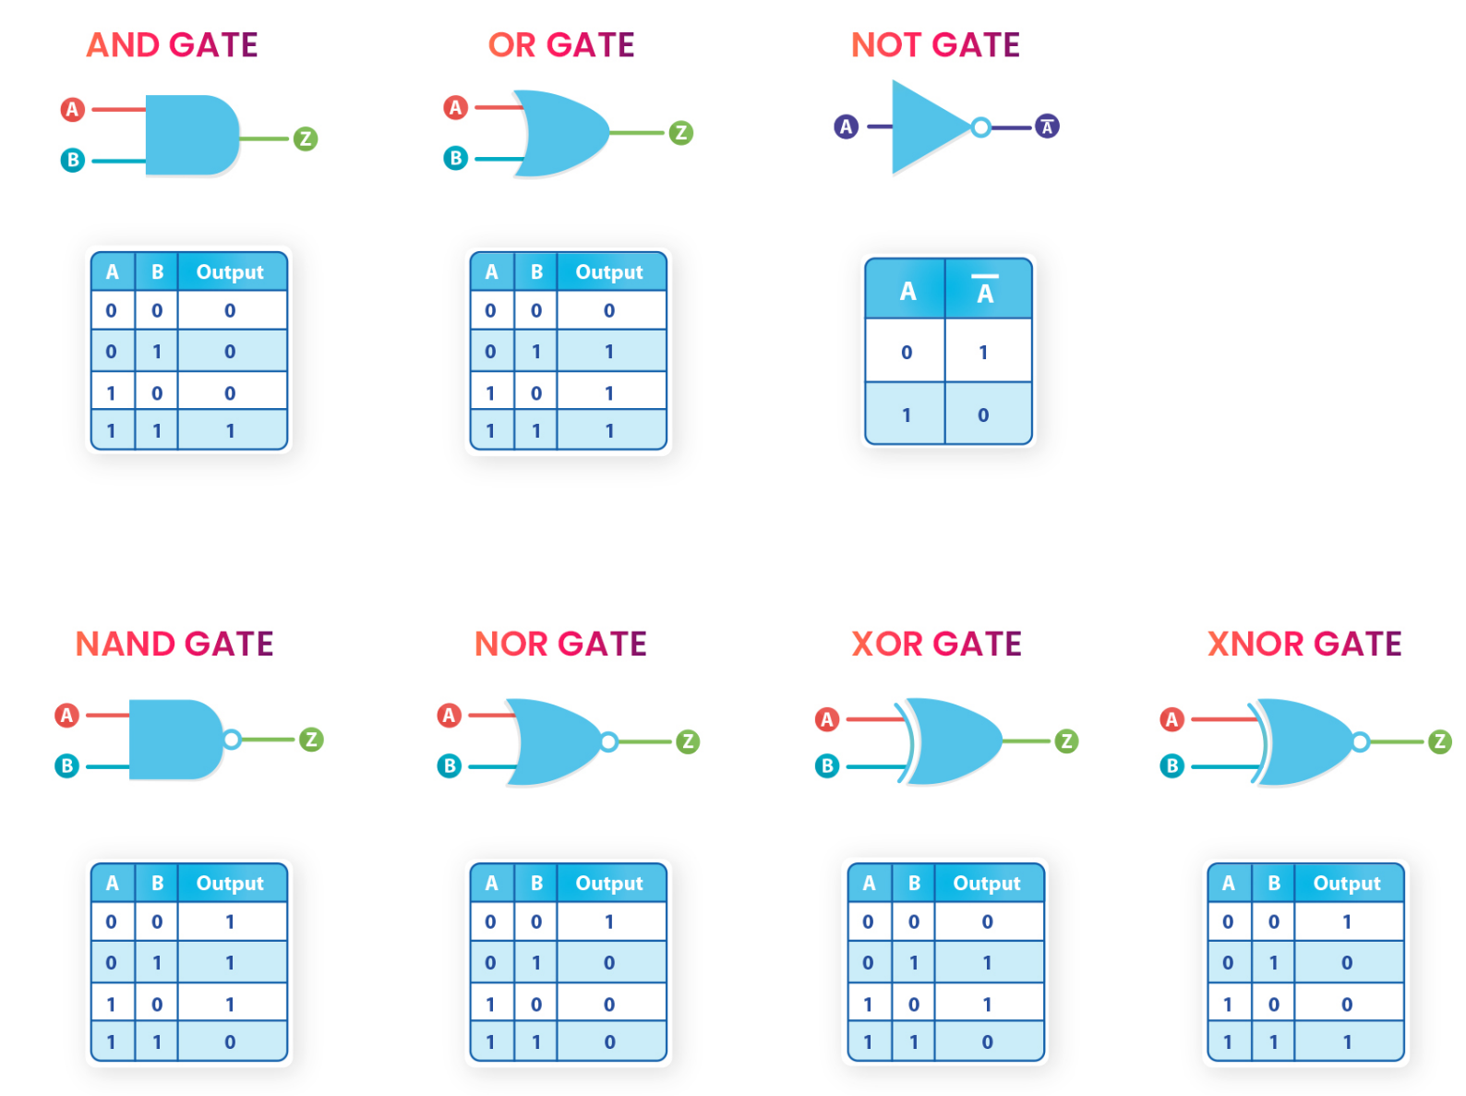

Dataflow model:
module allgate_DF ( a, b, yand,yor,ynot,ynand,ynor,yxor,yxnor );
input a,b;
output yand, yor, ynot, ynand, ynor, yxor, yxnor;

assign yand = a & b; // AND Operation
assign yor = a | b; // OR Operation
assign ynot = ~a ; // NOT Operation
assign ynand = ~(a & b); // NAND Operation
assign ynor = ~(a | b); //NOR Operation
assign yxor = a ^ b; //XOR Operation
assign yxnor =~(a^b); //XNOR Operation
endmodule // END of the module

Top-level verilog module in DE2-FPGA Kit
module lab1_ex1(SW,LEDG,LEDR);
input[17:0] SW;
output[7:0] LEDG;
output[17:0] LEDR;
assign LEDR=SW;
allgate_DF DUT(SW[1],SW[2],LEDG[5],LEDG[4],LEDG[3],LEDG[2],LEDG[1],LEDG[0]);
endmodule

Behavior Model :
module allgate_BH ( a, b, yand,yor,ynot,ynand,ynor,yxor,yxnor );
input a,b;
output yand, yor, ynot, ynand, ynor, yxor, yxnor;
reg yand, yor, ynot, ynand, ynor, yxor, yxnor;
always @(*)
begin
assign yand = a & b; // AND Operation
assign yor = a | b; // OR Operation
assign ynot = ~a ; // NOT Operation
assign ynand = ~(a & b); // NAND Operation
assign ynor = ~(a | b); //NOR Operation
assign yxor = a ^ b; //XOR Operation
assign yxnor =~(a^b); //XNOR Operation
end
endmodule // END of the module

Top-level verilog module to implement the allgate_BH module in DE2-FPGA Kit
module lab1_ex1(SW,LEDG,LEDR);
input[17:0] SW;
output[7:0] LEDG;
output[17:0] LEDR;
assign LEDR=SW;
allgate_BH DUT(SW[1],SW[2],LEDG[5],LEDG[4],LEDG[3],LEDG[2],LEDG[1],LEDG[0]);
endmodule

Gate-level (Structural Model) :

module allgate_GL ( a, b, yand,yor,ynot,ynand,ynor,yxor,yxnor );
input a,b;
output yand, yor, ynot, ynand, ynor, yxor, yxnor;

and G1(yand,a,b); // AND Operation
or G2(yor,a, b); // OR Operation
not G3(ynot,a) ; // NOT Operation
nand G4 (ynand,a,b); // NAND Operation
nor G5(ynor,a,b); //NOR Operation
xor G6(yxor,a,b); //XOR Operation
xnor G7(yxnor,a,b); //XNOR Operation
endmodule // END of the module

Top-level verilog module to implement the allgate_GL module in DE2-FPGA Kit
module lab1_ex1(SW,LEDG,LEDR);
input[17:0] SW;
output[7:0] LEDG;
output[17:0] LEDR;
assign LEDR=SW;

allgate_GL DUT(SW[1],SW[2],LEDG[5],LEDG[4],LEDG[3],LEDG[2],LEDG[1],LEDG[0]);
endmodule

Testbench Dataflow model:
`timescale 1ns/1ps

module allgate_DF_tb;

// Testbench signals
reg a, b;
wire yand, yor, ynot, ynand, ynor, yxor, yxnor;

// Instantiate the DUT
allgate_DF dut (
.a(a),
.b(b),
.yand(yand),
.yor(yor),
.ynot(ynot),
.ynand(ynand),
.ynor(ynor),
.yxor(yxor),
.yxnor(yxnor)
);

initial begin
$display("Time | a b | AND OR NOT NAND NOR XOR XNOR");

a = 0; b = 0; #5;
$display("%4t | %b %b | %b %b %b %b %b %b %b",
$time, a, b, yand, yor, ynot, ynand, ynor, yxor, yxnor);

a = 0; b = 1; #5;
$display("%4t | %b %b | %b %b %b %b %b %b %b",
$time, a, b, yand, yor, ynot, ynand, ynor, yxor, yxnor);

a = 1; b = 0; #5;
$display("%4t | %b %b | %b %b %b %b %b %b %b",
$time, a, b, yand, yor, ynot, ynand, ynor, yxor, yxnor);

a = 1; b = 1; #5;
$display("%4t | %b %b | %b %b %b %b %b %b %b",
$time, a, b, yand, yor, ynot, ynand, ynor, yxor, yxnor);
$finish;
end
endmodule

II.2 LAB EXPERIMENT 2 : WRITE VERILOG HDL CODES TO SIMULATE AND IMPLEMENT THE HALF ADDER CIRCUIT:

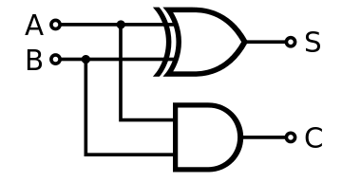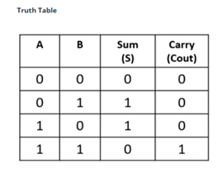

Dataflow model:
module half_adder_dataflow(input a, b, output s, Cout);
assign s = a ^ b;
assign Cout = a & b;
endmodule

Top level – data flow:
module lab1_ex2(SW,LEDG,LEDR);
input[3:0] SW;
output[2:0] LEDG;
output[3:0] LEDR;
assign LEDR=SW;

half_adder_dataflow DUT(SW[1],SW[2],LEDG[1],LEDG[0]);
endmodule

Behavior Model :
module half_adder_behavior(sum,carry,a,b );
output sum,carry;
input a,b;
reg sum,carry;
always @(a,b)
begin
sum <= a ^ b;
carry <= a&b ;
end
endmodule

Top level – Behavior Model:
module lab1_ex2 (
input [3:0] SW,
output [2:0] LEDG,
output [3:0] LEDR
);

assign LEDR = SW; // Mirror switches to red LEDs

// Instantiate half adder (SW[1] and SW[2] as inputs)
half_adder_behavior DUT (
.sum(LEDG[1]),
.carry(LEDG[0]),
.a(SW[1]),
.b(SW[2])
);

assign LEDG[2] = 1'b0; // unused LEDG bit (to avoid floating output)

endmodule

Gate-level (Structural Model) :
module half_adder_structeral(input a, b, output s, Cout);
xor G1(s,a,b);
and G2(Cout,a,b);
endmodule

Top level – Gate-level:
module lab1_ex2 (
input [3:0] SW,
output [2:0] LEDG,
output [3:0] LEDR
);

// Display switches on the red LEDs
assign LEDR = SW;

// Instantiate structural half adder
half_adder_structeral DUT (
.a(SW[1]),
.b(SW[2]),
.s(LEDG[1]),
.Cout(LEDG[0])
);

// LEDG[2] is unused → tie to 0
assign LEDG[2] = 1'b0;

endmodule

Testbench:
`timescale 1ns/1ps

module half_adder_dataflow_tb;

reg a, b; // Inputs to DUT
wire s, Cout; // Outputs from DUT

// Instantiate Device Under Test
half_adder_dataflow DUT (
.a(a),
.b(b),
.s(s),
.Cout(Cout)
);

initial begin
$display("Time | a b | s Cout");

// Test 00
a = 0; b = 0; #5;
$display("%4t | %b %b | %b %b", $time, a, b, s, Cout);

// Test 01
a = 0; b = 1; #5;
$display("%4t | %b %b | %b %b", $time, a, b, s, Cout);

// Test 10
a = 1; b = 0; #5;
$display("%4t | %b %b | %b %b", $time, a, b, s, Cout);

// Test 11
a = 1; b = 1; #5;
$display("%4t | %b %b | %b %b", $time, a, b, s, Cout);

$finish;
end

endmodule
II.3 EXPERIMENT 3: WRITE VERILOG HDL CODES TO SIMULATE AND IMPLEMENT THE FULL ADDER CIRCUIT:
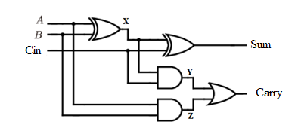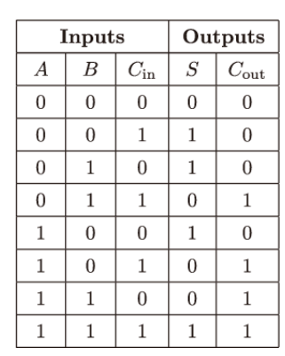

Top level Dataflow model:
module lab1_ex2 (
input [3:0] SW,
output [2:0] LEDG,
output [3:0] LEDR
);

// Mirror switches on red LEDs
assign LEDR = SW;

// Instantiate full adder:
// Inputs: a = SW[1], b = SW[2], cin = SW[0]
// Outputs: S → LEDG[0], Cout → LEDG[1]
full_adder_DF DUT (
.a(SW[1]),
.b(SW[2]),
.cin(SW[0]),
.S(LEDG[0]),
.Cout(LEDG[1])
);
endmodule

Dataflow model:
module full_adder_DF(input a, b, cin, output S, Cout);
assign S = a ^ b ^ cin;
assign Cout = (a & b) | (b & cin) | (a & cin);
endmodule

Top level Behavior Model using case :

module lab1_ex2 (
input [3:0] SW,
output [2:0] LEDG,
output [3:0] LEDR
);

// Show switches on RED LEDs
assign LEDR = SW;

// Instantiate FULL ADDER (behavioral)
full_adder_BH1 DUT (
.A(SW[0]),
.B(SW[1]),
.Cin(SW[2]),
.S(LEDG[1]),
.Cout(LEDG[0])
);
endmodule

Behavior Model using case :

full_adder_BH1 (input wire A, B, Cin, output reg S, output reg Cout);
always @(A or B or Cin)
begin

case (A | B | Cin)
3'b000: begin S = 0; Cout = 0; end
3'b001: begin S = 1; Cout = 0; end
3'b010: begin S = 1; Cout = 0; end
3'b011: begin S = 0; Cout = 1; end
3'b100: begin S = 1; Cout = 0; end
3'b101: begin S = 0; Cout = 1; end
3'b110: begin S = 0; Cout = 1; end
3'b111: begin S = 1; Cout = 1; end
endcase
end

Top level Behavior Model using if else :

module lab1_ex2 (
input [3:0] SW, // FPGA switches
output [2:0] LEDG, // Green LEDs
output [3:0] LEDR // Red LEDs
);

// Show switches directly on red LEDs
assign LEDR = SW;

// Instantiate FULL ADDER using SW[0], SW[1], SW[2]
full_adder DUT (
.A (SW[0]),
.B (SW[1]),
.Cin (SW[2]),
.S (LEDG[0]),
.Cout(LEDG[1])
);
endmodule

Behavior Model using if else :

module full_adder( A, B, Cin, S, Cout);

input wire A, B, Cin;
output reg S, Cout;

always @(A or B or Cin)
begin
if(A==0 && B==0 && Cin==0)
begin
S=0;
Cout=0;
end

else if(A==0 && B==0 && Cin==1)
begin
S=1;
Cout=0;
end

else if(A==0 && B==1 && Cin==0)
begin
S=1;
Cout=0;
end

else if(A==0 && B==1 && Cin==1)
begin
S=0;
Cout=1;
end

else if(A==1 && B==0 && Cin==0)
begin
S=1;
Cout=0;
end

else if(A==1 && B==0 && Cin==1)
begin
S=0;
Cout=1;
end

else if(A==1 && B==1 && Cin==0)
begin
S=0;
Cout=1;
end

else if(A==1 && B==1 && Cin==1)
begin
S=1;
Cout=1;
end

end

endmodule

Top level Behavior Model:
module lab1_ex2 (
input [3:0] SW, // FPGA switches
output [2:0] LEDG, // Green LEDs
output [3:0] LEDR // Red LEDs
);

// Show switch values on red LEDs
assign LEDR = SW;

// Connect the full adder
full_adder_BH DUT (
.a(SW[2]),
.b(SW[1]),
.c(SW[0]),
.sum(LEDG[1]),
.carry(LEDG[0])
);

// Unused LEDG bit
assign LEDG[2] = 1'b0;

endmodule

Behavior Model:
module full_adder_BH(a,b,c,sum,carry);
output sum,carry;
input a,b,c;
reg sum,carry;
always @ (a,b,c)
begin
sum <= a^ b^c;
carry <=(a&b) | (b&c) | (c&a);
end
endmodule

Top level Gate-level (Structural Model) :
module lab1_ex2 (
input [3:0] SW,
output [2:0] LEDG,
output [3:0] LEDR
);

// Show switches on red LEDs
assign LEDR = SW;

// Instantiate the full adder (structural)
full_adder_STRU DUT (
.A(SW[1]), // First input
.B(SW[2]), // Second input
.Cin(SW[0]), // Carry-in
.Sum(LEDG[1]), // Green LED shows SUM
.Carry(LEDG[0]) // Green LED shows CARRY
);

// Unused LEDG[2]
assign LEDG[2] = 1'b0;

endmodule

Gate-level (Structural Model) :
module full_adder_STRU(a,b,cin,Cum,Carry);
output Sum,Carry;
input A,B,Cin;
wire x,y,z;
xor g1(x,A,B);
xor g2(Sum,x,Cin);
and g3(y,x,Cin);
and g4(z,A,B);
or g5(Carry,x,y);
endmodule

II.4 EXPERIMENT 4 : WRITE VERILOG HDL CODES TO SIMULATE AND IMPLEMENT THE RIPPLE CARRY ADDER CIRCUIT:

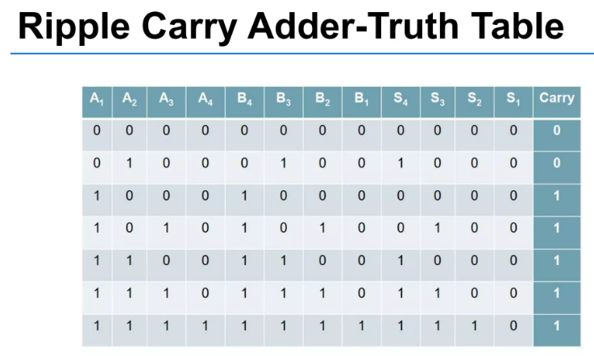
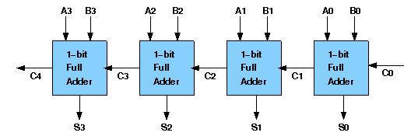

Top level Structural Model:
module lab1_ex2 (
input [9:0] SW, // use SW[7:0] as inputs
output [9:0] LEDR, // show inputs
output [9:0] LEDG // show adder results
);

assign LEDR = SW; // mirror all switches to RED LEDs

// Inputs from switches
wire Cin = SW[8]; // Carry in
wire [3:0] A = SW[3:0]; // Lower 4 switches
wire [3:0] B = SW[7:4]; // Upper 4 switches

// Outputs to LEDs
wire [3:0] S;
wire Cout;

// Structural 4-bit adder
four_bit_adder_STRU uut (
.cin(Cin),
.a(A),
.b(B),
.s(S),
.cout(Cout)
);

// Display result on green LEDs
assign LEDG[3:0] = S; // Sum bits
assign LEDG[4] = Cout; // Final carry
assign LEDG[9:5] = 5'b0; // unused LEDs

endmodule

Structural Model:
module full_adder_STRU(a,b,cin,Cum,Carry);
output Sum,Carry;
input A,B,Cin;
wire x,y,z;
xor g1(x,A,B);
xor g2(Sum,x,Cin);
and g3(y,x,Cin);
and g4(z,A,B);
or g5(Carry,x,y);
endmodule

module four_bit_adder_STRU(cin,a,b,s,cout);
input [3:0] a,b;
input cin;
output [3:0] s;
output cout;
wire [2:0] w_carry;
full_adder_STRU C1(a[0],b[0],cin,s[0], w_carry[0]);
full_adder_STRU C2(a[1],b[1], w_carry[0],s[1], w_carry[1]);
full_adder_STRU C3(a[2],b[2], w_carry[1],s[2], w_carry[2]);
full_adder_STRU C4(a[3],b[3], w_carry[2],s[3], cout);
endmodule

Top level Dataflow model:

module lab1_ex2(
input [8:0] SW, // 9 switches: A(4), B(4), Cin
output [3:0] LEDR, // Show sum (4 bits)
output [2:0] LEDG // Show Cout + unused LEDs
);

wire [3:0] sum;
wire cout;

// Assign output LEDs
assign LEDR = sum; // Show the 4-bit sum
assign LEDG[0] = cout; // Carry-out
assign LEDG[2:1] = 2'b00; // Unused Green LEDs

// Instantiate 4-bit adder
Four_bit_Adder_DF DUT (
.A(SW[3:0]), // Lower 4 switches
.B(SW[7:4]), // Next 4 switches
.Cin(SW[8]), // Cin = SW8
.Sum(sum),
.Cout(cout)
);

endmodule

Dataflow model:
module Four_bit_Adder_DF(A,B,Cin,Sum,Cout);
input [3:0] A,B;
input Cin;
output wire [3:0]Sum;
output wire Cout;
wire [4:0]temp;
assign temp=A+B+Cin;
assign Sum=temp[3:0];
assign Cout=temp[4];
endmodule

II.5 EXPERIMENT 5 :WRITE VERILOG HDL CODES TO SIMULATE AND IMPLEMENT 2:1 MULTIPLEXER CIRCUIT:

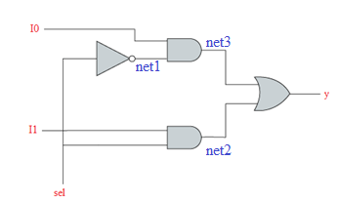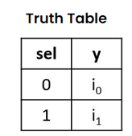

Top level Dataflow model:

module lab1_ex2 (
input [3:0] SW, // SW[0]=i0, SW[1]=i1, SW[2]=sel
output [2:0] LEDG, // LEDG[0] = mux output
output [3:0] LEDR // show all switches on red LEDs
);

assign LEDR = SW; // Display switch inputs

// Instantiate 2:1 multiplexer
mux21_data_flow DUT (
.i0 (SW[0]),
.i1 (SW[1]),
.sel(SW[2]),
.y (LEDG[0])
);

// Unused green LEDs → tie them low
assign LEDG[1] = 1'b0;
assign LEDG[2] = 1'b0;

endmodule

Dataflow model:
module mux21_data_flow(i0,i1,sel,y);
input i0,i1,sel;
output y;
assign y =(i0&(~sel))|(i1&sel);
endmodule

Top level Behavior Model :
module lab1_ex2 (
input [3:0] SW, // SW[0] = i0, SW[1] = i1, SW[2] = sel
output [2:0] LEDG, // LEDG[0] = output y
output [3:0] LEDR // show all switches
);

assign LEDR = SW; // mirror switches to red LEDs

// Instantiate MUX
mux21_Behavioural DUT (
.i0(SW[0]),
.i1(SW[1]),
.sel(SW[2]),
.y(LEDG[0])
);

// Unused LEDG[2:1] → tie them LOW
assign LEDG[1] = 1'b0;
assign LEDG[2] = 1'b0;

endmodule

Behavior Model :
module mux21_Behavioural (i0,i1,sel,y);
input i0,i1,sel;
output y;
reg y;
always@(*)
begin
if(sel==0) y=i0;
if(sel==1)y=i1;
end
endmodule

Top level Structural Model:
module lab1_ex2 (
input [3:0] SW,
output [2:0] LEDG,
output [3:0] LEDR
);

// Show switch values on red LEDs
assign LEDR = SW;

// Instantiate 2-to-1 MUX (structural version)
mux21_structural DUT (
.i0 (SW[0]), // Input 0
.i1 (SW[1]), // Input 1
.sel(SW[2]), // Selector
.y (LEDG[0]) // MUX output
);

// Unused LEDG bits set to 0 so they do not float
assign LEDG[1] = 1'b0;
assign LEDG[2] = 1'b0;

endmodule

Structural Model:

module mux21_structural(i0,i1,sel,y);
input i0,i1,sel;
output y;
wire net1,net2,net3;
not g1(net1,sel);
and g2(net2,i1,sel);
and g3(net3,i0,net1);
or g4(y,net3,net2);
endmodule

II.6 EXPERIMENT 6 : WRITE VERILOG HDL CODES TO SIMULATE AND IMPLEMENT 4:1 MULTIPLEXER CIRCUIT:

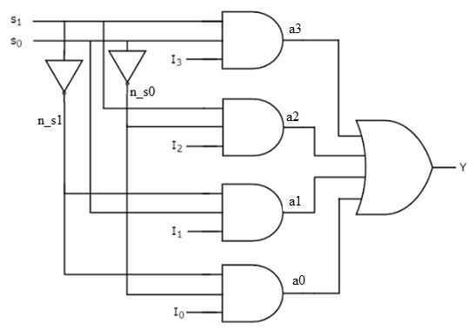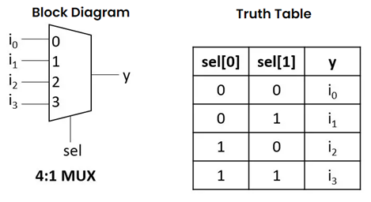

Top level Structural Model:

module lab1_ex2 (
input [5:0] SW, // 6 switches
output [2:0] LEDG, // green LEDs
output [5:0] LEDR // red LEDs
);

// Show all switch values on LEDR
assign LEDR = SW;

// Output y from multiplexer → LEDG[0]
mux41_strutural DUT (
.i0(SW[0]),
.i1(SW[1]),
.i2(SW[2]),
.i3(SW[3]),
.s0(SW[4]),
.s1(SW[5]),
.y(LEDG[0])
);

// Unused green LEDs → force to 0
assign LEDG[1] = 1'b0;
assign LEDG[2] = 1'b0;

endmodule

Top level Structural Model:
module lab1_ex2 (
input [7:0] SW, // Use SW[3:0] = data inputs, SW[5:4] = select lines
output [7:0] LEDR,
output [7:0] LEDG
);

// Show all switches on red LEDs
assign LEDR = SW;

// Instantiate 4-to-1 multiplexer
mux41_strutural M1 (
.i0(SW[0]), // data input 0
.i1(SW[1]), // data input 1
.i2(SW[2]), // data input 2
.i3(SW[3]), // data input 3
.s0(SW[4]), // select bit 0
.s1(SW[5]), // select bit 1
.y(LEDG[0]) // output shown on LEDG[0]
);

// Unused LEDG pins → tie low
assign LEDG[7:1] = 7'b0000000;

endmodule

Structural Model:

module mux41_strutural (i0,i1,i2,i3,s0,s1,y);
input i0,i1,i2,i3,s0,s1;
output y;
wire n_s0,n_s1, a0,a1,a2,a3;
not g0(n_s0,s0);
not g1(n_s1,s1);
and g2(a0,i0,n_s0,n_s1);
and g3(a1,i1,n_s1,s0);
and g4(a2,i2,s1,n_s0);
and g5(a3,i3,s1,s0);
or g6(y,a0,a1,a2,a3);
endmodule

Top level Dataflow model:
module lab1_ex2 (
input [5:0] SW, // SW[3:0] = inputs, SW[5:4] = select
output [3:0] LEDR, // mirrors switches
output [1:0] LEDG // outputs from muxes
);

// Mirror all switches onto red LEDs
assign LEDR = SW[3:0];

mux41_df MUX_DF (
.i0(SW[0]),
.i1(SW[1]),
.i2(SW[2]),
.i3(SW[3]),
.s0(SW[4]),
.s1(SW[5]),
.y(LEDG[0]) // DF output → LEDG[0]
);

//-------------------------
// 4:1 MUX (BEHAVIORAL version)
//-------------------------
mux41beh_v1 MUX_BEH (
.in({SW[3], SW[2], SW[1], SW[0]}), // 4-bit input vector
.s(SW[5:4]), // 2-bit select
.y(LEDG[1]) // behavioral output → LEDG[1]
);

endmodule

Dataflow model:
module mux41_df (i0,i1,i2,i3,s0,s1,y);
input i0,i1,i2,i3,s0,s1;
output y;
assign y= i0&(~s1)&(~s0) | i1 &(~s1)&s0 | i2&s1&(~s0) | i3&s1&s0;
endmodule

module mux41beh_v1(in,s,y );
output y ;
input [3:0] in ;
input [1:0] s ;
reg y;
always @ (in,s)
begin
if (s[0]==0&s[1]==0)
y <= in[0];
else if (s[0]==0&s[1]==1)
y <= in[1];
else if (s[0]==1&s[1]==0)
y <= in[2];
else
y <= in[3];
end
endmodule

Top level Behavior Model :

module lab1_ex2 (
input [3:0] SW, // SW[3:0] inputs
output [2:0] LEDG, // Only LEDG[0] used for output
output [3:0] LEDR // Mirroring switches
);

assign LEDR = SW; // Show all switches on RED LEDs

// Instantiate 4:1 MUX (behavioral v2)
mux41beh_v2 DUT (
.in(SW[3:0]), // 4 data inputs from switches
.s(SW[1:0]), // select bits: SW[1:0]
.y(LEDG[0]) // output → LEDG[0]
);

// Unused LEDs tied LOW
assign LEDG[1] = 0;
assign LEDG[2] = 0;

endmodule

Behavior Model :
module mux41beh_v2(in,s,y );
output y ;
input [3:0]in ;
input [1:0]s ;
reg y;
always@(in,s)
begin
case ({s[1],s[0]})
2'b00: y <= in[0];
2'b01: y <= in[1];
2'b10: y <= in[2];
2'b11: y <= in[3];
endcase
end
endmodule

II.7 EXPERIMENT 7 : WRITE VERILOG HDL CODES TO SIMULATE AND IMPLEMENT 16:1 MULTIPLEXER CIRCUIT USING STUCTURAL MODEL FROM FIVE 4:1 MULTIPLEXER MODULE

